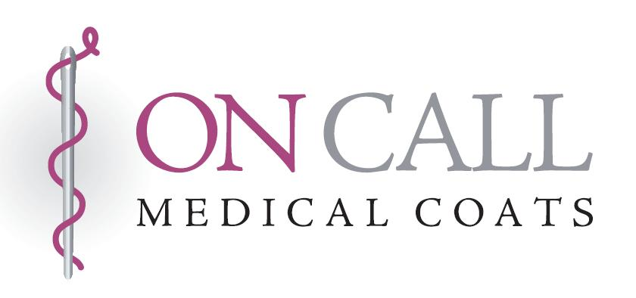
620 Franklin Avenue
Baltimore, MD 21221
Toll Free: 877.355.2898
Telephone: 410.574.2657
Fax: 410.574.6307
medicalcoats.com
Men’s Order Form
Order Date ______________
Sold To Ship To (If different From Sold To) Business Residence

______________________________________________________________ ______________________________________________________________
Name (Please Print ) Name

______________________________________________________________ ______________________________________________________________
Address Address

______________________________________________________________ ______________________________________________________________
City State Zip City State Zip

_____________________________________ _____________________________________ ______________________
Phone E-mail Fax

Style
Fabric | Content | All Styles
MW | Medium Weight 65% polyester / 35% cotton | $62.00
ST | Heavy Weight 65% polyester / 35% cotton | $66.00
HV | Medium Weight 100% cotton | $67.00
LT | Light Weight 65% polyester / 35% cotton | $64.00
RC | Heavy Weight 100% cotton twill | $65.00
HT | Fluid Repellent 100% cotton twill | $71.00
JF | Executive Weave 65% polyester / 35% cotton | $71.00
PF | Fresh® Poplin Antimicrobial 65% polyester / 35% cotton | $74.00
FT | Fresh® Twill Antimicrobial 70% polyester / 30% cotton | $75.00
OC | 100% Organic Cotton | $77.00

#1. Knee-Length Coat
Traditional Men’s Knee-Length
# 2. ¾ Length Coat
Traditional Men’s ¾ Length
# 3. Jacket
Traditional Waist-Length

Sizes

26 28 30 32 34 36 38 40
42 44 46 48 50* 52* 54* 56*
$8.00 surcharge for sizes 50+
Embroidery Copy (Please print one character or punctuation mark per block. Case and punctuation sensitive) Sentence form (Initial caps)
FABRIC | STYLE | SIZE | QUANTITY | PRICE
______________ | ______________ | ______________ | ______________ | $ ______________
______________ | ______________ | ______________ | ______________ | $ ______________
Alterations (inches) Sleeves $11.00 Add +____ Cut -____ Length $11.00 Add +____ Cut -____ |  |  |  | $ ______________
iPad Pocket Lower Outside $11.00/Pocket Left____ Right ____ Taper/Add Circumference $15.00 _______ |  |  |  | $ ______________
Belts Sewn Down $13.00 Pleat Size___ Inches Above Pocket ___ |  |  |  | $ ______________
Loose With Plastic Buttons $14.00 Loose Belt With Chef Buttons $15.50 |  |  |  | $ ______________
Zippers For Inside Pockets $13.00/Zipper Breast____ Left ____ Right ____ |  |  |  | $ ______________
Chef Buttons $10.00/Coat____ Deluxe stitching $15.00/Coat -1/4" edge & facing stitching____ |  |  |  | $ ______________
Silvertone Snaps $8.00/Coat____ Knit Cuffs $16.00/Coat____ Collarless $18.50/Coat____ |  |  |  | $ ______________
Embroidery Centered Above Left Breast Pocket 1 Line $9.00 2 Lines $13.00 3 Lines $16.00 |  |  |  | $ ______________
Logo_______________________________________ ($10.80 + depending on # of stitches) |  |  |  | $ ______________
Caduceus__ Staff__ Ribbon __ Flag # __ Left__ Right__ Sleeve__ Chest__$11.00-$15.00 Outside/Inside Color_________ |  |  |  | $ ______________
Athletic Swoosh Brush Brush738 Homeward Helvetica Athletic Narrow Cheltenham Courier Diana
Royal Blue Red Black Burgundy Navy Blue Teal Fuchsia Purple Yellow Powder Blue Bronze Forest Green Silver Orange Gold
Shipping $ ______________
Shipping & Handling: 1 Coat $12.00 Each Additional Coat $3.00 Rush charge: Add $11.50 per coat (Ships within 7-10 Business Days)
International orders: Standard Rates plus actual charge for global express (may require insurance) $ TBD
Maryland Tax (6%) Total $ ______________

__________________________________________ _______ ________ ______________________________________________________
Credit Card Number Exp date Sec code Signature

We reserve the right to correct inaccuracies during order input. Embroidered or altered coats are not returnable. Please allow 4 to 6 weeks for delivery. Rev 09/02/2015

